Exercises

1. Write a program for flipping two fair dice in 10,000 times, calling X is the summation of both dice that appear on each roll.

(a) Save the results of flipping dices into the variable x (list type).

(b) Find the values ​​of random variable X and save to variable X.

(c) Calculate the probability distribution function of the random variable X and store it in variable P (list type).

(d) Calculate the characteristic parameters of random variable X including: expectation, variance, standard deviation.

2. The probability density function of the normal distribution is determined by the formula:



The cumulative distribution function of the normal distribution is determined by the formula:

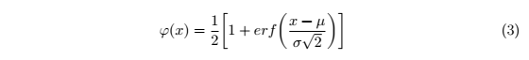

Where µ is the mean (expected) and σ is the standard deviation.

Write the probability density function and the cumulative distribution function of the normal distribution:

(a) Draw a graph representing the relationship between the random variable X and the function pmf_normal.

(b) Draw a graph representing the relationship between the random variable X and the function cdf_normal.

(c) For *X* is a normal random variable with mean μ=3 and variance σ2 = 16, using tưo previous to find *P*{2<*X* <7}

3. Read dataset population from file company-sales_data.csv

Read all month of toothpaste, shampoo, facecream and show them using line chart.

4. Find the frequency of each word in a given text (at least 300 words), and draw a histogram of the frequency of word with parameter bin = 30.